Software Requirement Specifications
Network Intrusion Detection System



Submitted by
Muqadas
F22BINFT1M01280

Submitted to
Sir Muzamill

Department of Information Technology
Faculty of Computing
The Islamia University of Bahawalpur

Meeting Details
Sr No | Details | Date | Supervisor Signature
Summary
This document describes the Software Requirement Specification (SRS) of the Network Intrusion Detection System (NIDS).
The project aims to monitor network traffic inside a controlled environment and detect abnormal or malicious activities such as ARP spoofing, ping flood, SYN flood, and port scanning.
Captured packets will be analyzed using Python, and alerts will be displayed on a real-time dashboard. The document includes system objectives, scope, requirements, and use cases.

Table of Contents
- Introduction
1.1. Purpose
1.2. Scope
1.3. Product Perspective
1.4. User Characteristics
1.5. Similar Apps and Systems / Literature Review
1.6. Proposed Technologies
- Requirements
2.1. Functional Requirements
2.2. Non-Functional Requirements
- Use Cases and Flow of Processes
3.1. Use Case 1
- References

- Introduction

This project is being developed to detect abnormal network behavior in a controlled environment such as a university lab or virtual machine setup.
The goal is to simulate normal and attack traffic to understand how network intrusion detection systems work and to provide an automated alerting system for administrators.
  - Purpose
The purpose of this project is to analyze live or captured network traffic and detect malicious activity using rule-based logic. Alerts will be displayed on a dashboard to help the administrator take timely action.
  - Scope
In Scope:
- Packet capture
- Traffic analysis
- Detection of ARP spoofing, SYN flood, ICMP flood, port scan
- Real-time dashboard alerts
- Logging
Out of Scope:
- Automatic blocking
- Machine learning models
- Real enterprise deployment
  - Product Perspective

This system is a standalone monitoring tool.
It does not replace an enterprise firewall or SIEM but provides a lightweight educational NIDS that fits inside a virtual network environment.
  - User Characteristics

Administrator: Views alerts and monitors dashboard
Student/Tester: Performs simulations and captures data
  - Similar apps and systems/Literature Review
- Wireshark: Captures packets but does not automatically detect attacks
- Snort: Full-featured IDS but complex to configure
- Suricata: High-performance IDS/IPS system
These tools are advanced; the proposed system is simpler and demonstration-focused.
  - Proposed Technologies
- Python
- Scapy / PyShark
- Streamlit (Dashboard)
- Wireshark / tcpdump
- VirtualBox or VMware
- Git & GitHub
- Requirements

The project consists of monitoring network traffic, detecting attack patterns, and showing alerts.
Packets will be captured from a VM, analyzed through Python code, and displayed through an interactive dashboard.
  - Function Requirements

2.1.1 Packet Capture
- Name: FR001
- Purpose: Capture network packets from a selected interface.
- User(s): Administrator, Tester
- Input: Live network interface or pcap file
- Output: List of captured packets

2.1.2 Attack Detection
- Name: FR002
- Purpose: Detect abnormal traffic patterns such as ARP spoofing, SYN flood, ICMP flood, and port scanning.
- User(s): Administrator
- Input: Packet stream
- Output: Detected attack event

2.1.3 Dashboard Alert
- Name: FR003
- Purpose: Display real-time alerts to the administrator.
- User(s): Administrator
- Input: Attack Detection Event
- Output: Visual Alert on Dashboard

2.1.4 Logging
- Name: FR004
- Purpose: Store detection events in log file for audit.
- User(s): Administrator
- Input: Attack detection details
- Output: Log entry

  - Non-Functional Requirements
- System should be easy to operate.
- Dashboard must respond within 2 seconds.
- System must work in isolated virtual environment.
- Logs must be secure from unauthorized editing.
- System should run on Windows or Linux.

- Use Cases and Flow of Processes

3.1. Use Case 1
ID | UC001
Name | Detect Intrusion in Network
Description | This use case describes how the system captures network traffic, analyzes packets, detects abnormal activity, and generates alerts for the administrator.
Requirement(s) | FR001
Actor(s) | System (NIDS), Administrator
Precondition | Monitoring interface must be active and the system must be running.
Postcondition | System detects normal or suspicious activity and generates an alert if required.

Basic Flow Basic Flow
- System starts monitoring the network interface.
- System captures all incoming and outgoing packets.
3.System analyzes packet fields (IP, protocol, size, frequency).
4.System compares activity against normal thresholds.
5,If suspicious activity is found, the system generates an alert.
6.Alert is displayed on the administrator dashboard.

Alternative Flow
- Administrator applies filters to capture only specific packet types.
- Administrator manually starts or stops monitoring.

Exceptions
- Network interface unavailable.
- Packet capture fails to start.
- No packets available for analysis.
- Dashboard fails to update alert.

Diagrams:

1.FlowChart
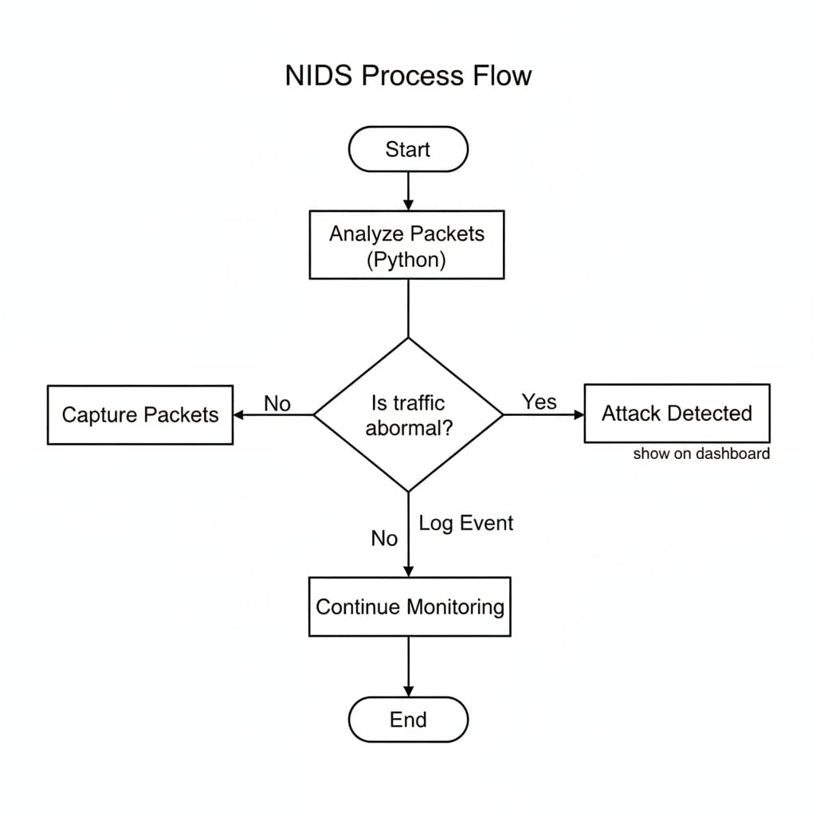
Use Case Diagram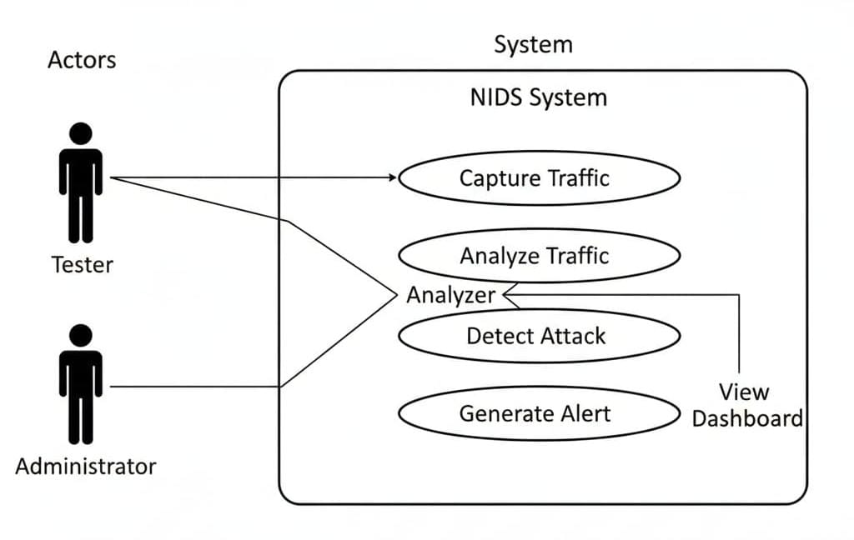
NIDS Context Diagram
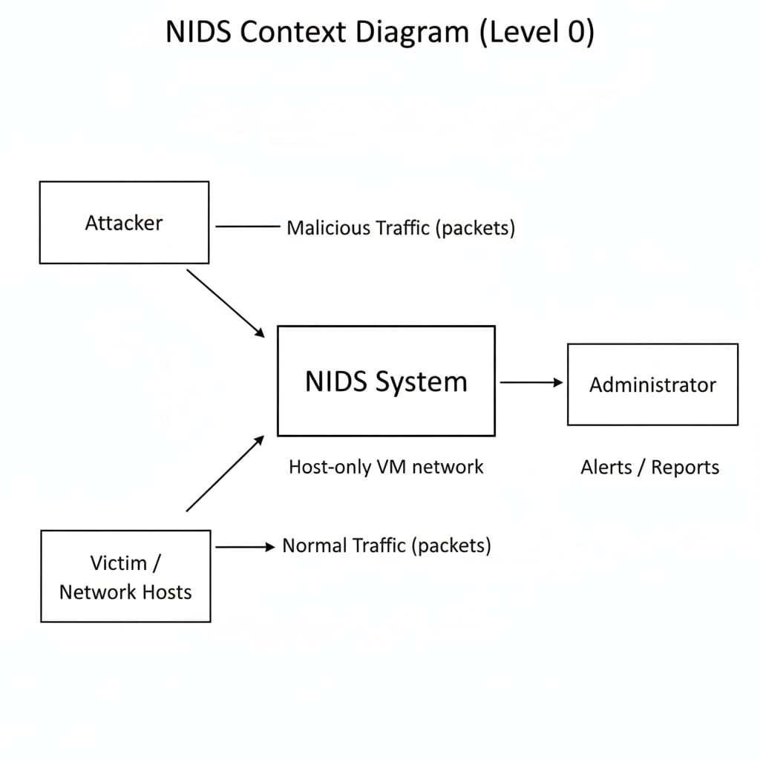

References
- J. P. Anderson, "Computer Security Threat Monitoring and Surveillance," James P. Anderson Co., Fort Washington, PA, USA, 1980.
- D. E. Denning, "An Intrusion-Detection Model," IEEE Transactions on Software Engineering, vol. SE-13, no. 2, pp. 222–232, 1987.
- S. Axelsson, "Intrusion Detection Systems: A Survey and Taxonomy," Chalmers University of Technology, Technical Report 99-15, 2000.

